26. Species Concepts and Speciation *(RHM: Chapter 22)*

______________________________________________________________________________

I. Introduction: Diversity of Life *(501-505)*

A. Extent of Variation

## B. Speciation: Amplification of Variation

C. The Biological Species Concept and Its Flexibility

D. Models of Speciation

II. Allopatric (= Geographic) Speciation *(507-509)* A. Two Stages of the Process

B. Geographic Isolation

C. Genetic Divergence

1. The agents of evolution

2. Population size and peripheral isolates

D. Secondary Contact

# E. Examples of Allopatric Speciation

III. Sympatric Speciation *(509-511)*

A. Definition

B. Occurrence in Phytophagous Insects

IV. Abrupt Speciation *(512-517)*

A. Polyploidy

B. Mechanism

C. Importance

V. The Maintenance of Separate Gene Pools *(505-507)*

A. Isolating Mechanisms

1. Definition

2. Two types of isolating mechanisms

B. Postzygotic Isolating Mechanisms

1. General classes of postzygotic isolating mechanisms

2. Importance/action with respect to natural selection

C. Prezygotic Isolating Mechanisms

1. Behavioral mechanisms

2. Sexual selection and character displacement

26-1

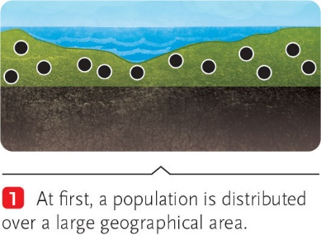 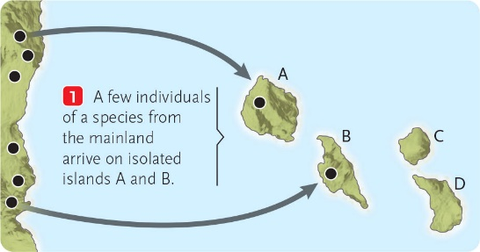

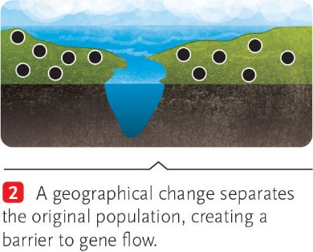 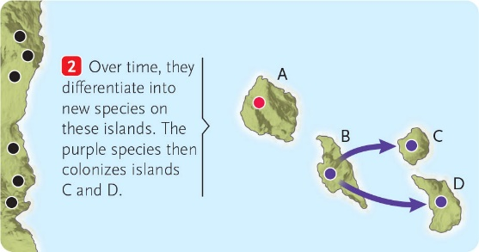

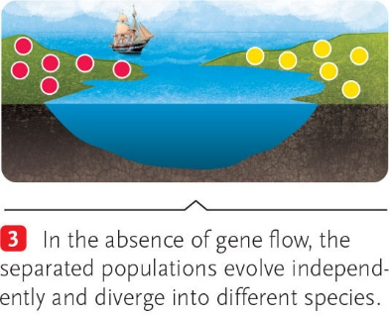 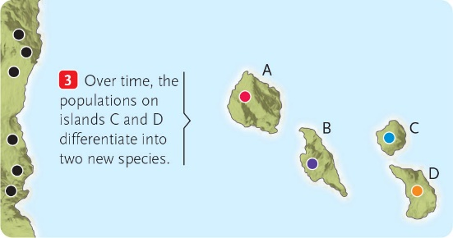

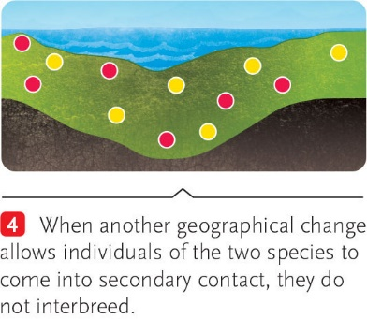 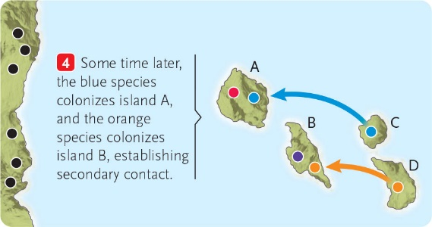

26-2

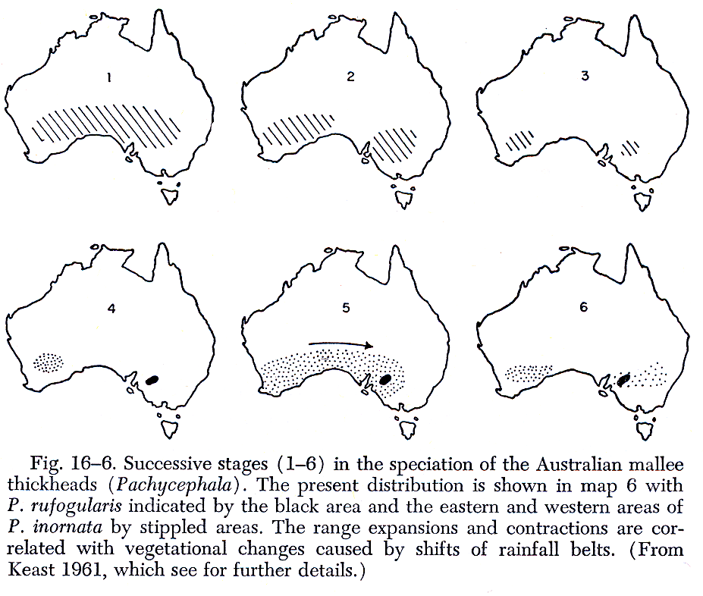

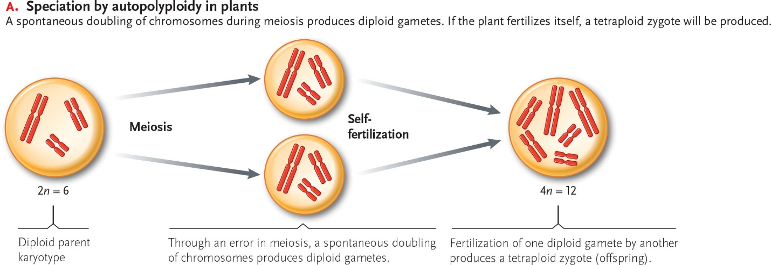

26-3

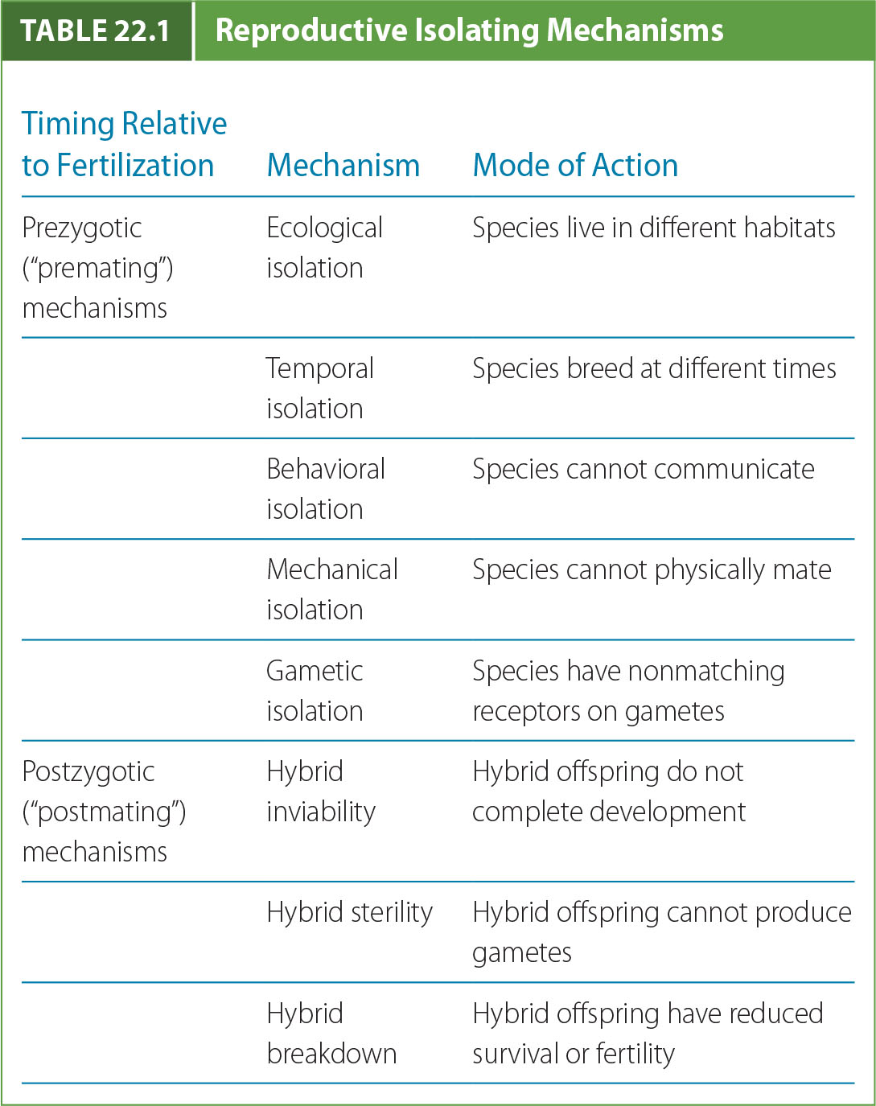

26-4

Sexual Selection

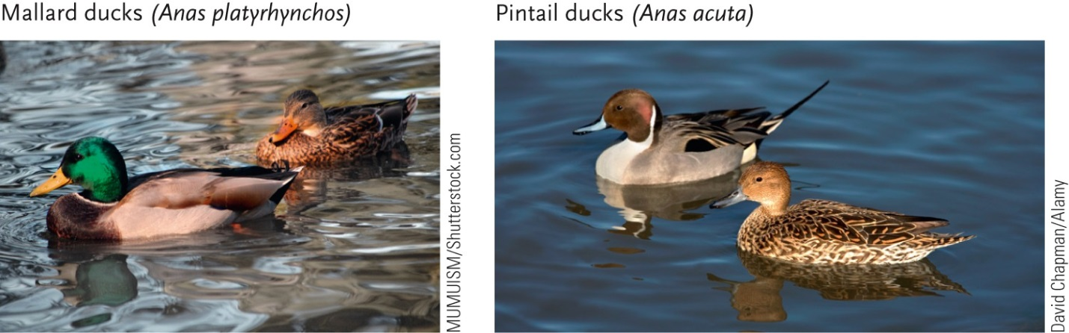

Reproductive Character Displacement

